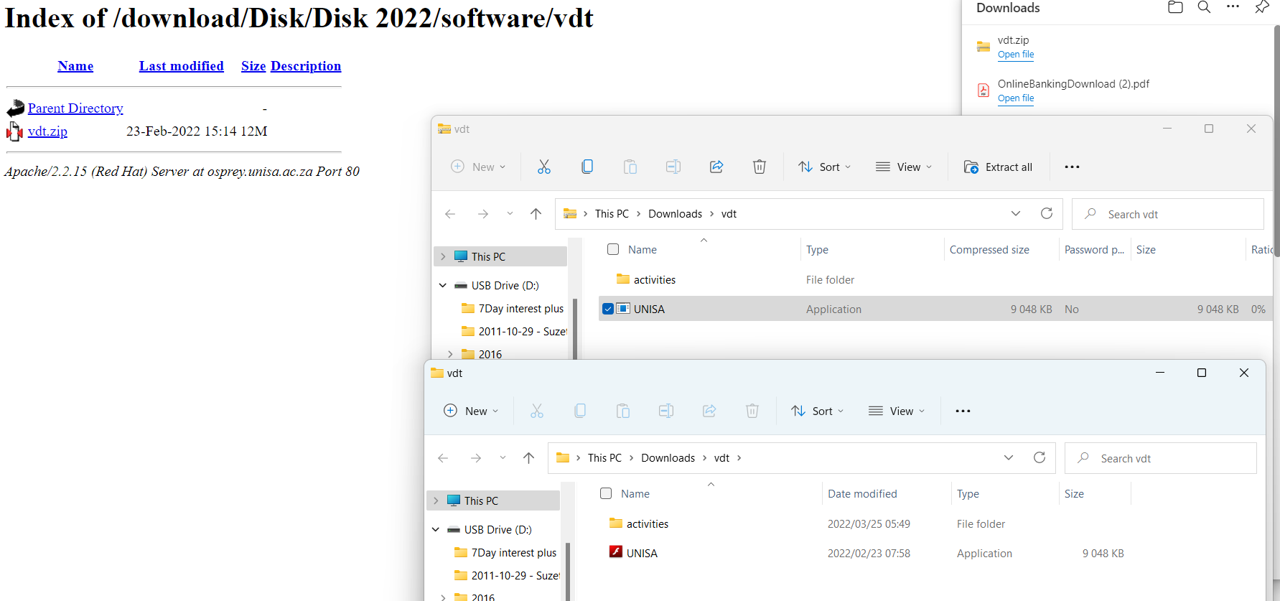

3.Double-click on the UNISA application and Extract all to unzip it.

1.Click on vdt.zip to download it

2.Click on open file under the Downloads

4.Double-click on UNISA application to run the Variable Diagrams tutorial